MUSA presents…

**Recreational**

**Math Night**

Thursday, September 8, 2016

1015 Evans, 6pm

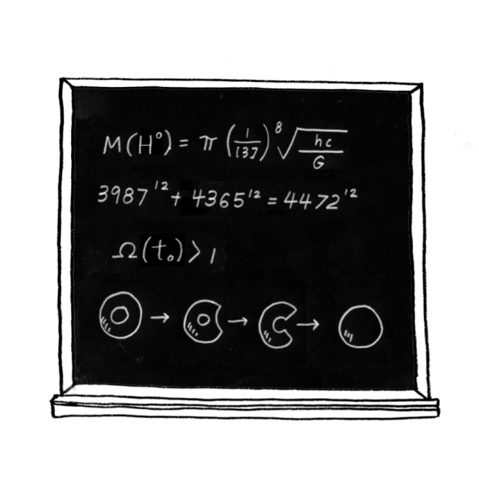

**First Math Monday**

**Berkeley mini Math Tournament**

Come to MUSA’s first Recreational Math Night! Eat provided snacks, listen to a brief talk on colorings of graphs, and for the rest of the meeting, enjoy diving into some fun and interesting math problems written around the room. From 5:30 to 6pm, MUSA is also hosting an Ice Cream Social! Bring any friend who shares our interest in ice cream.

The Berkeley mini Math Tournament (Fall) and Berkeley Math Tournament (Spring) are math competitions held on campus for middle school and high school students, respectively. We’re looking for volunteers to help us! There will be an introductory BmMT meeting on **Wednesday, September 7 at 6:30pm in 740 Evans.** The BMT Website:

[bmt.berkeley.edu](http://bmt.berkeley.edu/)

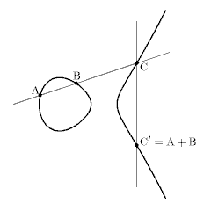

On **Monday, September 12 from**

**5-6pm in 740 Evans**, we will be having our first Math Monday talk. Come learn about a new, extracurricular topic in math research